NASA Exoplanet Explorer Database System
Members: Areeba Ali & Shandana Shah
Program: BS Artificial Intelligence
Semester: 4th (B)
Instructor: Sir Ali Hasan

Milestone | Date | Version | Remarks
ERD Diagram & Schema | 25/April/2026 | 1.0 | Flowchart
Update Schema & ERD diagram | May 2026 | 1.1

ERD Diagram
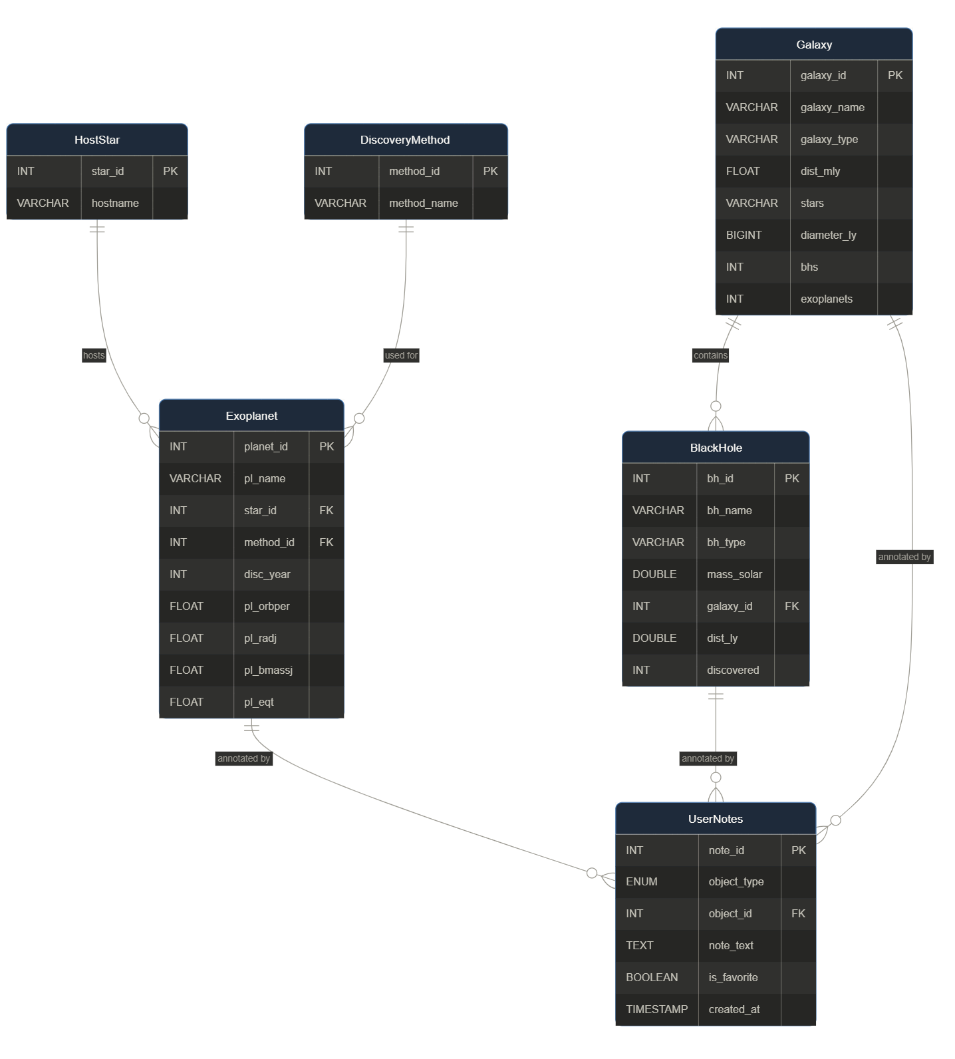

Relational Database Schema

Table 1: Exoplanet

Attribute | Data Type | Constraints | Website Field | Description
planet_id | INT | PRIMARY KEY, AUTO_INCREMENT | id (e.g. 'e1') | Surrogate primary key
pl_name | VARCHAR(100) | NOT NULL, UNIQUE | name | Planet name (e.g. TRAPPIST-1 e)
star_id | INT | FOREIGN KEY -> HostStar, NOT NULL | star | Host star reference
method_id | INT | FOREIGN KEY -> DiscoveryMethod | method | Discovery method reference
disc_year | INT | NOT NULL | year | Year of confirmed discovery
pl_orbper | FLOAT | NULL | orbper | Orbital period (days)
pl_radj | FLOAT | NULL | radius | Planet radius (Jupiter radii)
pl_bmassj | FLOAT | NULL | mass | Planet mass (Jupiter masses)
pl_eqt | FLOAT | NULL | temp | Equilibrium temperature (Kelvin)

Table 2: HostStar

Attribute | Data Type | Constraints | Website Field | Description
star_id | INT | PRIMARY KEY, AUTO_INCREMENT | — | Surrogate primary key
hostname | VARCHAR(100) | NOT NULL, UNIQUE | star | Star name (e.g. TRAPPIST-1)

Table 3: DiscoveryMethod
Attribute | Data Type | Constraints | Website Field | Description
method_id | INT | PRIMARY KEY, AUTO_INCREMENT | — | Surrogate primary key
method_name | VARCHAR(100) | NOT NULL, UNIQUE | method | Method name (e.g. Transit)

Table 4: BlackHole ( NEW )

Attribute | Data Type | Constraints | Website Field | Description
bh_id | INT | PRIMARY KEY, AUTO_INCREMENT | id (e.g. 'b1') | Surrogate primary key
bh_name | VARCHAR(150) | NOT NULL, UNIQUE | name | Black hole name (e.g. Cygnus X-1)
bh_type | VARCHAR(50) | NOT NULL | type | Stellar or Supermassive
mass_solar | DOUBLE | NULL | mass_solar | Mass in solar masses
galaxy_id | INT | FOREIGN KEY -> Galaxy, NULL | galaxy | Host galaxy reference
dist_ly | DOUBLE | NULL | dist_ly | Distance from Earth (light-years)
discovered | INT | NULL | discovered | Year of discovery

Table 5: Galaxy ( NEW )

Attribute | Data Type | Constraints | Website Field | Description
galaxy_id | INT | PRIMARY KEY, AUTO_INCREMENT | id (e.g. 'g1') | Surrogate primary key
galaxy_name | VARCHAR(150) | NOT NULL, UNIQUE | name | Galaxy name (e.g. Milky Way)
galaxy_type | VARCHAR(50) | NULL | type | Spiral, Elliptical, or Irregular
dist_mly | FLOAT | NULL | dist_mly | Distance from Earth (million light-years)
stars | VARCHAR(50) | NULL | stars | Estimated star count (e.g. 200-400B)
diameter_ly | BIGINT | NULL | diameter_ly | Diameter in light-years
bhs | INT | DEFAULT 0 | bhs | Number of known black holes
exoplanets | INT | DEFAULT 0 | exoplanets | Number of known exoplanets

Table 6: UserNotes

Attribute | Data Type | Constraints | Website Field | Description
note_id | INT | PRIMARY KEY, AUTO_INCREMENT | — | Surrogate primary key
object_type | ENUM | NOT NULL ('exoplanet','blackhole','galaxy') | id prefix | Type of object being annotated
object_id | INT | NOT NULL | id number | PK of the referenced object
note_text | TEXT | NULL | notes[id] | User annotation text
is_favorite | BOOLEAN | DEFAULT FALSE | favourites[id] | Marks object as favourite
created_at | TIMESTAMP | DEFAULT CURRENT_TIMESTAMP | — | When the note was saved

Relationships Summary
Relationship | Cardinality | Description
HostStar → Exoplanet | 1 : M | One star can host many exoplanets
DiscoveryMethod → Exoplanet | 1 : M | One method can apply to many exoplanets
Galaxy → BlackHole | 1 : M | One galaxy can contain many black holes
Exoplanet → UserNotes | 1 : M | One exoplanet can have many user notes / favourites
BlackHole → UserNotes | 1 : M | One black hole can have many user notes / favourites
Galaxy → UserNotes | 1 : M | One galaxy can have many user notes / favourites

